

1200 North Elm Street
Greensboro, NC 27401-1020
336.832.7000

Frequently Asked Questions Regarding the Pharmacy Technician Academy (PTA):

- Is this program for Cone Health Employees only?

Yes, only current Cone Health Employees are eligible for the PTA. Further, you must have been in your current position since July 1st, 2025.

- When does the academy program start?

The pharmacy team will be enrolling students for one cohort this spring to start the program on
July 27th, 2026

- What is the application process?

- Interested candidates will be required to successfully complete a reading comprehension and math assessment exam as part of the application process. Assessment exams will be scheduled through May 22nd, 2026.
- Upon passing the pre-assessment exams with a score of 85% or better, candidates will have a short screening interview
- Based on pre-assessment scores and screening interview, an offer may be extended to interview with the pharmacy department.
- After interviews, acceptance decisions will be made on or about June 26th, 2026.
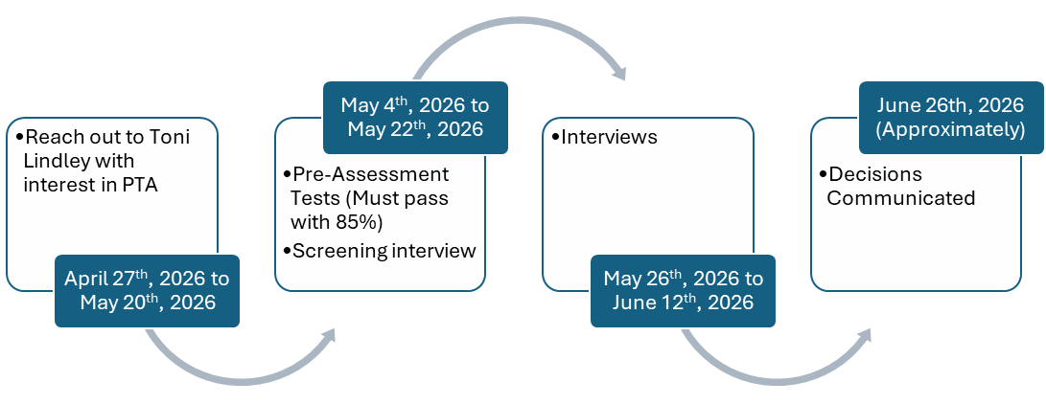
- What happens if I don’t complete the program?

We will make every effort to help students complete the PTA. In the event the student is unable to move forward, this will be handled on a case-by-case basis in partnership with our HR Business partners.

- What is the attendance policy?

The attendance policy follows the standard Cone Attendance Policy. Additionally, due to the limited time of the PTA, a Maximum of 2 PAL days will be granted to allow completion of the program in a timely manner.

Progression through the attendance policy could delay transfer into a certified position.

- Will I be paid during the PTA?

PTA participants are paid as full-time employees during the program. Employees are eligible for full-time benefits and can keep their current benefits upon transfer. During the PTA, employees accrue PAL, but limited days will be granted during the academy.

- Will I be able to return to my current location after completion of the PTA?

Upon graduation from the PTA and successful completion of the PTCB exam, a full-time certified pharmacy technician position is guaranteed. However, the location and shift cannot be guaranteed at the start of the PTA.

- Will I need to drive to Moses Cone Hospital every day?
Most students will be based at a Greensboro campus and rotate between Moses Cone, Union Square and Wesley Long for experiences. For candidates coming from Alamance Regional, there is an opportunity to spend some rotation time on the ARMC campus. During the education portion of the PTA, there are hands-on simulation days that are built in to enhance the online module learning. These simulation days usually take place 1 time per week and require in-person attendance at Union Square or Moses Cone campus, so the entire PTA class is together.

