Clinical Instructor
Reference Guide

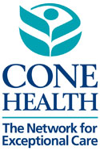

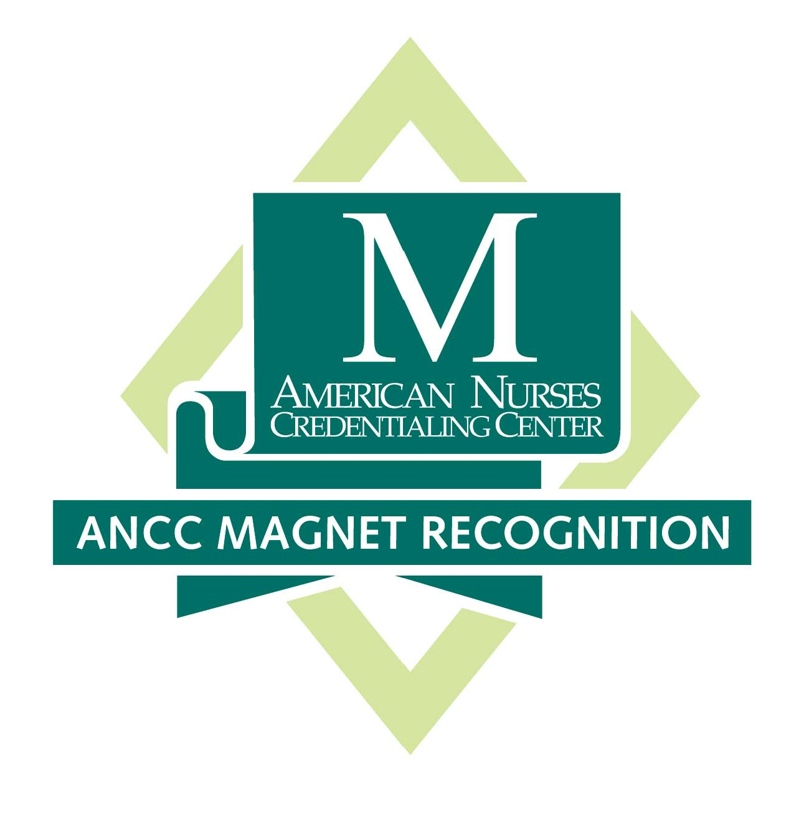

7. 2019 CL

Contents

- New Instructor Orientation Requirements page 3
- New Instructor Orientation Verification Form* page 4
- Department Clinical Orientation Guidelines page 5
- Instructor Commitments for a Successful Clinical page 7
- Out-Rotation Guidelines page 9
- CI/Student Information Form for clinical Departments* page 10
- Clinical Department Orientation Form* page 11
- Nursing and Clinical Student Policy page 14
- Annual Clinical Instructor Competency* page 17
- Sample Student Assignment Form page 19
- CHL Reactivation / Co-Signatures page 20
- CO-Signature Instructions page 21
- Resources: Clinical Key & Clinical Skills page 22
- Medication Safety and High-Alert Medications page 23
(Medication and Bar-Code Scanning see P&P)
- HLC / Pyxis Access Information page 25
- New Department Orientation Form* page 26
- Fast Facts page 27

* Denotes forms that must be turned in

The Nursing Student Resources webpage is the landing site to reach the Clinical Instructor and other related pages. All current information, forms in this document and other forms related to clinical are posted here. The Student Surveys are posted on the Undergraduate Student page.

www.conehealth.com/nursingstudentresources

Contact Information:

- staff.education@conehealth.com

- Connie Lewter - connie.lewter@conehealth.com or 336.553.6053

- Breten Chrismon – breten.chrismon@conehealth.com or 336. 553.6064

- See the Clinical Department Information Document for specific department contact information. Email format to contact Department Leadership and other Cone Health employees: firstname.lastname@conehealth.com

Clinical Instructor Orientation Requirements

Welcome to Cone Health! We value the work you do and support you and your students in working collaboratively with our staff to provide excellent patient care while experiencing valuable learning opportunities. Cone Health requires all new Clinical Instructors (CI) and those who have not been at Cone Health for a year or more to complete the following Orientation requirements:

Step 1. Access the Nursing Student Resources web site:
https://www.conehealth.com/health-care-professionals/nursing-student-resources/
Click on the Clinical Instructor link.
  - Clinical Instructor Reference Guide (CIRG)
- Review New Instructor Orientation Requirements
- Print and bring to meeting with Connie Lewter
  - Note other important information found on Nursing Student Resources Web Site
    - Student Clinical Policy, Department Information
    - Clinical Department Orientation Form
    - End of semester Student and Instructor Surveys
Step 2. Contact Connie Lewter, connie.lewter@conehealth.com to arrange a New Clinical Instructor Orientation meeting at Union Square Campus, 124 East Gate City Boulevard, 2nd floor office # 254L.
- Allow 1.5 hours for meeting. Print and bring the Clinical Instructor Reference Guide.
- Your school Education Partner, may have already submitted the Badge and CHL access/training requests for you. If not:
  - Remind your Education Partner to submit the Cone HealthLink (CHL) (Epic EMR training) request form. Training may be available through your school. If not, contact brenda.taylor@conehealth.com to register for a class on Thursdays, 8a-4p at the Nursing Education Center.
  - Submit Badge Request form to Security and you will pick it up as directed on the form
- You will be added to the Clinical Instructor email distribution list to receive periodic updates and be given instructions for Pyxis and HLC access.

Step 3. You will be registered for New Employee Nursing Clinical Orientation. Orientation is held on Tuesdays 8am – 5pm in the Nursing Education Center at 200 E. Northwood, Greensboro, NC. Parking is provided in the upper lot on Olive Street.
- Attend Tuesday New Employee Orientation: *Cone Health nurses are exempt.
- 8a – 12n Self-Guided Clinical and Nursing Orientation modules (5th floor, #503).
- Lunch with Nursing Executive team
- 1p-5p Equipment Orientation (4th floor. #440) Exempt from the glucometer competency
- Attend IV class Wednesday morning 8am – 9:45am (4th floor). *Cone Health nurses are exempt.
Step 5. Department Orientation
- Contact Department leadership to schedule 16 hours orientation. See ‘Clinical Department Information’ to find contact information for department leadership to arrange orientation.
  - Cone Health Employees - 8 hours or more as needed, if not on the department where the employee works. If on the employee’s work department, as needed to be determined with the department leadership. Cone Health Employees are not permitted to use Employee ID (badge, computer log in), perform CBG testing, or function as a staff member while in the instructor role. Please complete and submit requests for a 2nd CHL log-in and a 2nd badge per the instructions on the request forms. Forms are included in this document.

For more information contact: Connie Lewter, connie.lewter@conehealth.com 336. 553.6053

New Instructor Orientation Verification Form
Welcome! Orientation to Cone Health is an integral part to your success as a clinical instructor and this process is designed to help you transition into your new role.
Submission of this completed form is required prior to working as a Clinical Instructor at Cone Health.
Date: __________
Name (Print): _______________________________ School: ______________________

Phone: ________________ Email: ______________________________________________________

New Employee Clinical Orientation: * Cone Health Nurse exempt _____ (√)

Date: __________ (Tuesday 8a-5p) NPDS signature validation _____________________

New Instructor Meeting: Date: _______ Signature verification _______ __
Clinical Faculty Handbook _____ Access to Clinical Placement website ______

Department Orientation: 16 hrs (8hrs for Cone Health Nurses, as needed if staff on the department)

Date: __________ # of hours ___ Dept. Staff verification: _____________________________

Date: __________ # of hours ___ Dept. Staff verification: _____________________________

Date: __________ # of hours ___ Dept. Staff verification: _____________________________

CHL Access & Training: ______ (√)

Education Partner to submit the CHL Multi-User Exhibit A access and training request form.

Instructor Badge: ______ (√)
Education Partner to submit Badge Request form to Security Services. Call 336.832.7849 to schedule appointment to pick up.

Pyxis: ______ (√)

HLC Access: ______ (√)

Additional requirements:
- Verification of annual completion of the Core Orientation and Cone Health Orientation Power Point presentations must be maintained at the school. *Cone Health nurses are exempt
- Annual Clinical Instructor Competency due every Fall semester or prior to annual work
- New Department Orientation (8 hours) - complete and submit a New Department Orientation Verification form if you are new to a department or have not been on the department for a year or more.

CI Sign: ______________________________ Date:

NPDS II Clinical Education Coordinator: ________________________

Clinical Instructor
Department Specific Orientation Guide

- To be precepted by experienced nurse on the department for 16 hours (8 hrs employee)
  - Ask for a department orientation
  - Ask to work with preceptor on their assignment
  - Describe your background to department leadership and preceptor so they can better determine what you need to be well oriented.
  - Introduce yourself to as many staff members as you can
  - Ask for department specific information
  - Interact with various staff, patients and families
- Obtain Information regarding:
  - Basic unit information
    - Number of beds
    - Staffing ratio (number of patient’s per nurse) / how assignments are made
    - Most common diagnoses
    - Common meds
    - Common treatments
  - Emergency Equipment and Department Equipment & Supplies
    - Crash cart location
    - Fire safety: location of extinguishers, pull boxes and evacuation route
    - Call bell system / Telemetry monitor process
    - Phone system
    - Location of PPE, patient care equipment, wheelchairs, gurneys
    - Access to clean and dirty supply, equipment, utility, break, medication, nutrition and linen rooms
  - Clinical Assignments
    - How to best make and obtain staff input for assignment; Pre-clinical, Day of clinical
  - Posting student assignment for staff access (required)
    - Where to post
    - Is there any department specific information that should be added?
    - Assignment Form Required Information:
      - Date / School / Program & Level of Students
      - Faculty name / phone number / email
      - Student’s names / assigned Room number & patient’s initials
      - Start and End time
      - Student’s responsibilities
        - Medication administration
        - Patient care ADLS
        - Documentation
        - Treatments / dressing changes

- Basic Access Needs
  - Pyxis Access - Tutorial required then request by department leadership to local pharmacy
  - Clean / Dirty Supply access - location and codes

- Report Reports are at 7a and 7p and done as walking rounds. It is important for student groups to begin their clinical day at the same time as the nurses to support effective workflow. Communication is critical in establishing positive working relationships and avoiding errors.
  - To best facilitate a positive clinical experience, Instructors are required to:
    - Make and post assignment
    - At the beginning of the shift, communicate briefly with each nurse who will be working with a student to introduce self, student and confirm assignment.
    - Ensure students are present at patients’ rooms or with nurse and ready for report. The clinical schedule will need to allow time for this to occur.
    - Direct the student in how to communicate effectively in reporting off prior to leaving department.
    - At the end of the shift, communicate briefly with each nurse who worked with a student to confirm the assignment is completed and obtain any insights.

Documentation Cone requires Clinical Instructors to Co-Sign student notes. The IT Department has to add this function to the CI CHL log-in. If you do not have this functionality, contact Connie Lewter.
- From the student’s note, select the attest button.
- Free text your statement or use the pre-build smart phrase.
- Sign the attestation. The note will display the attestation statement along with the student note.
- Update the attestation statement with the edit button.
- The individual school program may have their own additional practice requirements.

- Hands on demonstration of Equipment
  - Monitors, vital sign equipment, special scales, beds, bedside tables, alarms
  - Common equipment (feeding pumps, lift equip etc.)
- Pre and Post Conference room reservations – Ask about using department conference room and if not available contact appropriate campus person to make a reservation.
- Discussion
Meet with department leadership and discuss factors that help or hinder the learning experience for students:
- Staff expectations of students and of instructor
- Course objectives for this experience; guidelines for interacting with student
- System-wide Student Orientation talking points
- Caution against posting any patient care related comments on social media
- No cell phones are allowed in patient care areas; give students the department number for significant others to reach them if needed.
- Students are not permitted to print out any material and must not use any patient identifiers on notes they take off the department.
- Caution regarding topics of discussion in public areas.

Information for Successful Collaborative Clinical Experiences

Cone Health is committed to supporting our community and school affiliates by providing quality experiences for students and instructors. Some initiatives include:
- A culture that values collaboration with our affiliate partners to provide exceptional experiences
- Welcoming Orientations to incoming students
- Pass Port clinical on-boarding and orientation process for students and instructors.
- On-line Clinical Placement process
- New Instructor Orientation
- Multiple clinical opportunities throughout the Cone Health system
- Mosby’s Clinical Key and Skills resource on the Intranet
- Frequent updates of new initiatives for Clinical Instructors
- Instructor department orientation and competencies
- CHL (Epic EMR) access and training
- Cone Health photo ID badges

Cone Health Pre and Post Conference Room Reservations
- Group meetings cannot be conducted in public areas. The first option for obtaining pre and post conference rooms is asking the department director about the department conference room.
- If the department cannot provide a private area for your conferences, send your request information using the format below to iLearn@conehealth.com

Date(s):
Time:
Campus:
# of people:
Room preference:
Organizer:
Comments:

See the Nursing Student Resources web site for more information:
https://www.conehealth.com/health-care-professionals/nursing-student-resources/
Email is the best way to reach me and I will respond ASAP,

In addition to Cone Health Commitments, successful student learning experiences are the result of multiple instructor commitments.

Instructor Commitment to Students
- Student Supervision and Teaching
- It is the primary responsibility of the instructor to teach, supervise, and engage students while on the department. Staff are committed to helping students as availability allows; their primary responsibility is to patient care.
- Student clinical shifts begin when the department shifts begin. Ensure students are present at patients’ rooms or with nurse and ready for report. The clinical schedule will need to allow time for this to occur.
- Ensure compliance with Cone Health dress code policy including a Cone Health photo ID on and visible while in clinical.
- Students are not permitted on the department without instructor present.
- Verify annual Core and Cone Health Orientation has been completed
- Provide Department Orientation
  - Have students sign and give the signed Clinical Department Orientation Document to your school Education Partner who will reconcile with the request for the department and submit to Staff Education. *Due the first week of clinical
- Documentation - Instructors make a CHL Work List and include all of the patients the students are working with each day of clinical. Schools may require instructor co-signatures
Faculty Commitment to Department Staff and Patients
- Maintaining open communication between faculty/student/and staff is imperative to patient safety and fosters a collegial relationship. It encourages a climate of collaboration and mentorship and adds to the overall positive clinical experiences between student, faculty, and staff.
- Prior to the start of the clinical day, faculty must post an Assignment form with School name, date, contact information and a list of student patient-care responsibilities on the department.
- Confirm the assignment with the patient’s primary nurse.
- At the beginning of the shift and throughout the day, faculty should encourage collaboration between the student and patient’s nurse related to patient expectations and how the student can assist with patient care during the clinical experience.
- Absence from clinical: If, for any reason, faculty finds it necessary to cancel a scheduled clinical day you must notify the department staff of your decision.
- Protect Privacy: Conferences are prohibited in public areas.
- Printed materials with patient identifiers are not permitted off the department.

Faculty Commitment to Department Leadership and Staff
Contact Department Leadership at least one week prior to the first clinical day (See Clinical Department Information posted on the Clinical Placement website to find leadership phone contact information).
Offer an opportunity for the department leaders to ask questions and provide any necessary information.
Provide department leadership with the following information in writing:
  - Type of Program, level of student
  - Clinical Course Objectives and specifically what outcomes are expected from this clinical experience
    - Clinical Schedule – days scheduled on department, start/end date and any days scheduled off the department.
    - List of students – if an out-rotation, state when each student will be on the department
- Clinical Hours: Begin the clinical day to enable students to be available to participate in the reporting process. This eliminates miscommunication, and facilitates the department workflow.
- Attempts should always be made to first resolve any conflicts with the staff involved. Discuss any unresolved concerns with the Department Director or other department leadership.
- Honor timeframes for department breaks from hosting students between semesters.

Faculty Commitment to Clinical Education Coordinator
- Submit the Clinical Orientation Agreement by the end of the first week of clinical. This verifies that students have been oriented to the clinical department.
- Direct students complete the Clinical Exit Survey, for each department they have clinical experiences in. See Survey Monkey Link on the Clinical Placement Website.
- Notify Clinical Education Coordinator for any concerns or issues not resolved on department.
- Provide information for any student Safety Zone Portal reports.

Cone Health Out-Rotations

All out-rotation requests are arranged through the Cone Health Staff Education Department using the Group Clinical Request Form. These requests are submitted exclusively through the School’s Education Partner affiliated with Cone Health. Unless otherwise agreed upon, direct contact with department leadership for clinical placement is not made until approval has been obtained through Staff Education.
Out-rotations are defined as 1 – 2 day specialty department clinical experiences, previously arranged for students in a clinical group on a Cone Health hospital campus. The purpose of the out-rotation is to supplement the clinical group department experience. This is a non-instructor led experience with the student shadowing or providing direct patient care under the supervision of the appropriate department staff as instructor guidelines permit. The Instructor is responsible for contacting the department and providing:
- Course syllabus
- Specific clinical objectives and guidelines for the out-rotation clinical experience
- Schedule with students names and dates of rotations
- Instructor contact information
Instructors are to be on the same hospital campus as where the out-rotation experience occurs unless previously approved, by the department leadership, to be as a different campus at the time of the clinical experience. Out-rotations are not to be scheduled independent of a clinical group scheduled at Cone Health.
Out-rotation sites are listed on the Group Clinical Request form posted on the Clinical Placement website.

CLINICAL INSTRUCTOR /STUDENT INFORMATION for the DEPARTMENT
This form is required prior to beginning the clinical rotation on the department

DEPT: DATE:

SCHOOL:

PROGRAM / LEVEL: (ex. First year, First Term, First Clinical Rotation)

DATES AND TIME OF ROTATION:

CONFERENCE TIME: Pre and post conferences

INSTRUCTOR CONTACT INFORMATION:
Name:
Home:
Work:
Cell:
Email:
* Contact Instructor for student contact information

CLINICAL FOCUS:

RESPONSIBILITIES OF STUDENTS:

STUDENT COMMUNICATION EXPECTATIONS:
- Absence: Directed to call department
- Report: Student to be prepared for shift report from staff
- Reporting Off: To RN and NA responsible for student’s assigned patient

INSTRUCTOR RESPONSIBILITIES:
- Instructor department orientation
- Provide required information to department – Copy of this form, course syllabus with clinical objectives, clinical schedule and list of student names in clinical group.
- Student department orientation – submit signed Clinical Department Orientation form to school Education Partner
- Post Assignment each clinical day – see Instructor Reference for details
- Work collaboratively with each nurse working with students; connect to each nurse working with the students at the beginning and the end of the rotation.

* Attach List of Clinical Group of Students first and last names

Students CANNOT take verbal or telephone orders or assume any responsibility for blood administration, patient controlled analgesia, OR ANY SKILL THAT REQUIRES COMPETENCY BEYOND THE GENERALIST NURSE. Student medication administration must be under direct supervision.

The Clinical Instructor is required to complete this form and give it to the department leadership prior to beginning the clinical rotation.
Keep this form in the designated Student Binder accessible to all staff.


Cone Health Clinical Department Orientation
Commitments to Care – iCare
At Cone Health, we follow the Commitments to Care, also called iCARE. As a student of Cone Health, I am expected to role model the iCARE commitments (Communication, Accountability, Respect, and Empowerment) in my daily interactions with patients, families, coworkers, volunteers, vendors and others.

National Patient Safety Goals
The purpose of the National Patient Safety Goals is to improve patient safety. Providing a culture of safety is a priority of Cone Health and as an affiliate of the system, I understand I am required to support these safety goals. In the event of questions regarding the specific role I play in supporting these goals I understand I am to address these with my instructor and department leadership.

Confidentiality
As a student of Cone Health, I understand and agree that I must keep confidential System information and all medical and patient information in confidence. I am not allowed to access any confidential information, medical record of computer system unless necessary to perform my duties. I may not access or ask someone to obtain for me my medical information or that of family/others, unless needed to perform my duties. I may not discuss, review and/or reveal in any way confidential information that I may have as a result of my employment with the System unless to do so is within my assigned duties. It has been explained to me and I understand that I am fully accountable for my actions. Further, I understand that violation of System policies regarding privacy and confidentiality or any other breach of confidentiality will result in immediate disciplinary action, up to and including termination of my student experience. I understand there is a Privacy Line (336-832-7075) if I have any concerns after talking with my instructor and department leadership or need information, that the call may be anonymous and that the System has a policy of non-retaliation.

Corporate Compliance
It is the intent of the System to maintain sound, ethical standards in all that we do. Policies and procedures in support of these standards are placed throughout the organization. I understand that as a student of the System I am required to support those standards. I understand that there is a Corporate Compliance Hotline (336-832-8888 or toll free 866-506-8890) if I have concerns after talking with my instructor and department leadership, that the call may be anonymous, and that the System has a policy of non-retaliation.

Safety/Quality Concerns
The System, The Joint Commission and the Division of Health Service Regulation (DHSR) are committed to patient safety and quality care. If I have a concern regarding safety or quality, I should:
1. Notify my instructor and department leadership 2. If appropriate, have the incident entered into the Safety Zone Portal.
3. If I have an ongoing concern after seeking the assistance of my instructor and department leadership, I may discuss the matter in a confidential manner by using the System’s Compliance Hotline. The hotline number is 832-8888 or toll free 1-866-506-8890. If I continue to have concerns, I have the right to contact The Joint Commission directly at 1-800-994-6610 or complaint@jointcomission.org or contact DHSR directly at 1-800-624-3004. The System, The Joint Commission, and DHSR support a non-retaliation reporting environment.

I acknowledge that I completed the Core and Cone Health Orientation and received information on the following topics:

- Introduction to Cone Health | - Back Safety
- Safety Codes | - Confidentiality
- Fire Safety | - Corporate Compliance
- Hazardous Materials Safety | - False Claims Act
- Infection Control | - Notice of Privacy Practices (HIPAA)
- Advance Directives | - National Patient Safety Goals
- Staff Requests for Patient Care Exemptions | - Patient Rights
- Harassment Prevention | - Reporting Safety & Quality Concerns
- Cultural Competency / Diversity | - Handwashing
- Abuse and Neglect  - Commitments to Care, iCARE | - Safety Zone Portal (SZP)

I have received the information on the iCARE Commitments, Confidentiality, Corporate Compliance and Safety and Quality concerns and the National Patient Safety Goals related to the standards expected of all Cone Health employees, and commit to abide by them. By my signature, I confirm that this Acknowledgement has been reviewed by me.

Cone Health
Clinical Department Orientation Agreement Signature Page

By signing this document, I have completed the Student/Faculty Orientation Agreement and agree to abide by Cone Health policies while associated with Cone Health and to seek assistance with and/or clarification of these policies if needed. I have experienced a unit specific orientation.

____________________ __________________ ________ __________________
Print - Faculty Name Faculty Signature Date Semester

______________________ ___________________ ______________________________
School / Program Hospital/Department Program Clinical Course

_________________________ ______________________
Clinical Day(s) Clinical Hours (example- 7a-7p)

For Students - Please print first and last name Student Signatures

This agreement must be completed and returned to your school for reconciliation to the confirmed clinical placement request form. The school will submit all clinical group forms with a verification of reconciliation statement to the Staff Education Department before new requests for the upcoming semester will be accepted.
Staff Education Staff.Education@conehealth.com

Policies and Procedures

Policy Title:
Nursing and Allied Health Students at Cone Health, Clinical and Nonclinical*
Department Responsible:  Nursing | Policy Code:  ER-SED-2010-64 | Effective Date:  March 21, 2017 | Next Review/Revision Date:  March 2020
Title of Person Responsible:  Manager, Staff Education | Approval Council:  Nursing Policy and Procedure Council |  | Date Approved by Council:  March 2017

PURPOSE:
Cone Health is dedicated to providing a safe healthcare environment for all patients, as well as a learning environment for all students who have been approved for a learning experience at Cone Health. Students will have access to a wide array of educational opportunities designed to facilitate the development of highly skilled and knowledgeable professional caregivers. In partnership with educational institutions, students will practice under the direct supervision of faculty instructors and/or Cone Health registered nurse (RN) preceptors, as well as other licensed practitioners. The licensed professional, whether faculty instructor or Cone Health preceptor, will supervise all care provided by the student in the clinical setting.

DEFINITIONS:
- Faculty: Individual employed by Cone Health, or affiliated with Cone Health through a program at an educational institution, to instruct and supervise students as part of the program.
- Learning experience: A structured experience at Cone Health in which a student works to meet academic program learning objectives under the guidance of a faculty instructor or Cone Health preceptor.
- Preceptor: An employee or affiliate with practicing privileges at Cone Health who facilitates student learning and provides guidance and evaluation of students at Cone Health as part of the learning experience.
- Program: Nursing or allied health program of study at an educational institution affiliated with Cone Health, where students are enrolled and receive all preplacement training and education related to their field.
- Student: An individual officially enrolled in a nursing or allied health educational institution program of study who participates in a learning experience at any of the Cone Health sites. Students include undergraduate, graduate, and licensed professionals returning to the clinical setting for a learning experience as part of their educational program.

POLICY:

Overview
Students may perform activities that are permitted within the scope of practice for the program’s level of education and clinical agency policy. Students will be supervised by a licensed faculty/preceptor, RN, or other licensed healthcare professional. No student will be allowed to perform a procedure that requires specialty training and/or certification beyond their practice discipline.

Scope
This policy applies to all Cone Health facilities and to all students as defined above.

Dress Code for Students/Faculty
- Students must wear the designated school uniform or abide by the unit-specific attire (ex. scrubs, business casual). Students/faculty must wear an authorized Cone Health student / faculty photo identification badge while on duty and identify themselves as a student/faculty at all times. Additionally, students and faculty must adhere to the Cone Health policy for Standards of Appearance and Dress Code and any specific guidelines of the departments in which they have learning experiences. Student/faculty uniforms must be easily differentiated from Cone Health employee uniforms.
- Cone Health employees participating in clinical experiences as a student or faculty must identify themselves as a student/faculty and wear an authorized Cone Health student / faculty photo identification badge while in the student/faculty role. They may not wear their employee Cone Health badges while serving in a student/faculty role.

Faculty Instructor/Student Orientation
- Cone Health requires all newly hired faculty instructors, and those who have had clinical teaching experience in Cone Health but have been away for a year or more, to attend the General Clinical & Nursing Orientation and complete the Cone Health Instructor Orientation process. Cone Health employees new to the instructor role may be exempt from the General Clinical & Nursing Orientation component of the Cone Health Instructor Orientation process.
- Instructors will complete unit-based orientation prior to supervising students on the unit. Instructors will contact the director of the department PRIOR to the clinical experience to arrange this orientation.
- Instructors must contact the department director to share course and clinical objectives, the student list, scheduled dates and times of clinical experiences, and faculty contact information PRIOR to beginning the clinical experience. Failure to submit this information will result in the clinical student/group not being allowed in the department. The instructor will be responsible for notifying the department director when schedule changes affect the presence or absence of students in the clinical area.
- Each semester, and as changes occur, the educational institution is required to submit a roster of students and all faculty instructors supervising students in clinical rotations no later than the first day of the clinical experience. This list should be sent electronically to the Cone Health Staff Education Mailbox: staff.education@conehealth.com.
- Instructors are responsible for orienting students to Cone Health prior to their arrival on the department according to the Cone Health Student and Instructor Orientation Process. This information is current on the Cone Health Clinical Placement website.
- Annually, instructors and students must complete the online Core Orientation process and the Cone Health Orientation process found on the Cone Health Clinical Placement website.

Supervision of Students
- Student supervision is the responsibility of the faculty instructor or Cone Health preceptor.
- Faculty instructors must be present in the facility at all times and be available by phone or pager. Exception: For precepted or graduate students, a faculty instructor must be available by phone or pager while the student is within Cone Health.
- Ultimate responsibility for patient care rests with the patient’s physician and Cone Health staff assigned to the patient. Physicians must be employed or privileged at Cone Health. At any time the Cone Health primary caregiver deems necessary, he/she can assume care of any patient assigned to a student.

Computer Use by Students
- All students documenting patient care must complete the appropriate Cone HealthLink computer training class. Upon successful completion of the documentation training exercise the student will be given a unique computer access code for documenting patient care.
- It is Cone Health’s policy that each person accessing computer systems or documenting patient care have unique credentialing to do so. Accessing under another person’s credentials is cause for termination of employment and could result in termination from the clinical experience per the Clinical Education Agreement with the School. (See policy on Electronic Communications)
- Cone Health employees must obtain student logins and may not use their employee logins while performing in their student/faculty role.

Documentation/Charting by Students
- Students may document in the patient’s medical record with the supervision of the faculty instructor or Cone Health preceptor.
- Students must comply with all Cone Health documentation policies.

Medications
- Students administering medications must be under the direct supervision of a registered nurse or other licensed healthcare professional in the specialty of study. It is required that nursing students be observed by their clinical faculty, by the RN assigned to the student, or by the RN preceptor in the preparation, administration, and documentation of all medications. Medications requiring a second witness must be witnessed by two licensed nurses.
- Students will not be issued passwords for the automated medication dispensing system. These medications must be obtained through the faculty instructor or Cone Health preceptor.
- Administering and charting medications will be according to the Cone Health policy on Medication Administration and Bar Code Scanning.
- Students may not administer investigational drugs or any drugs that require specialized training to administer (e.g., chemotherapeutic drugs, vasoactive drugs, and intravenous conscious sedation).
- Students are not permitted to conduct narcotic counts.

*Note: Some disciplines may have additional policies with requirements that pertain specifically to students of those disciplines.

PREVIOUS REVISION/REVIEW DATES:
Date | Reviewed | Revised | Notes
October 1, 2005 |  |  | Original effective date.
April 2012
April 2013
June 2013
June 11, 2015 |  |  | Updated formatting to match current policy template; no content changes.
March 21, 2017 |  | X | Revised to include allied health and non-clinical students.

ANNUAL CLINICAL INSTRUCTOR COMPETENCY PATHWAY

Clinical Instructor Name: Date:

Email: Phone:

School:

CH Campus(s) / Department(s):

Student Learning & Patient Focus: Demonstrates basic knowledge of hospital and department specific policies and procedures, Clinical Instructor responsibilities and general nursing competencies.

Instructor competencies can be verified through one of the following of Methods of Validation:
D = Department Orientation preceptor, Qualified Observer/ Employee or assigned resource staff nurse Initials and signature
AR / SE= achieved in Academic role / Self Evaluation
CHE / SE = Cone Health employee / Self Evaluation
NA / SE= department competency is Not Applicable to the Instructor role / Self Evaluation

Competency / Learning Activity | Method of Validation / Initials
Compliance
CORE Orientation Power Point presentation; verification documentation maintained at the school
Cone Health Orientation Power Point presentation; verification documentation maintained at the school
Flu Vaccine (not required for Summer semester) - documentation maintained at the school
Instructor Role
Review Clinical Instructor Reference Guide (CIRG) regarding the following:
- Clinical Resources – Clinical Key and Clinical Skills – verified ability to access
- CHL
- Pyxis
- Student Policy
- Medication Administration / High Alert Medications
- SZP process
- Required communication and information to departments and department leadership
- Daily assignment form
Access the Nursing Student Experiences / Clinical Instructor and Students webpages for forms and surveys
System-wide Nursing Competencies
Fall Prevention – Safe patient handling. Verbalizes understanding of policy, procedures and resources
Pain Management - Verbalizes understanding of policy, procedures and resources
Skin / Wound / Pressure Ulcer care - Verbalizes understanding of policy, procedures and resources
Restraints – Verbalizes alternative measures, procedures for appropriate use. Demonstrates quick release slip knot.
Demonstrates knowledge of early activation of Emergency Response Teams. Verbalizes how to recognize the event and call for help.
- Code Blue
- Rapid Response Team (RRT)
- Code Stroke
Prevention of Hospital Acquired Infections
- Multi-Drug resistant Organisms (MDRO)
- Surgical Site Infections (SSI)
- Indwelling Urinary Catheters (CAUTI)
- C-Diff
- Hand Hygiene
- Isolation protocols
Department Specific Competencies

Annual Department Competencies

List the Department specific competencies and the validation method you used to meet the requirement. Complete this component of the Annual Nursing Instructor Competency Pathway for every department where you have clinical with students. Do not leave blank; if all competencies are beyond the nursing instructor role, write Annual department competencies are beyond the generalist nurse. Then write N/A in the signature space.

Clinical Instructor Specific Department Competencies
Department leaders may determine there are specific competencies for clinical instructors such as Safe Patient Handling equipment, IV care and medications, wound care or anything that pertains to the student role on the department. These specific competencies are to be listed and when completed, initialed by department staff.* Do not leave blank; if there are no identified CI department competencies write No identified CI department competencies. Then write N/A in the signature space.

Instructor competencies can be verified through one of the following of Methods of Validation:
D = Department Orientation preceptor, Qualified Observer/ Employee or assigned resource staff nurse Initials and signature
AR / SE= achieved in Academic role / Self Evaluation
CHE / SE = Cone Health employee / Self Evaluation
NA / SE= department competency is Not Applicable to the Instructor role / Self Evaluation

Write Cone Health Hospital Campus / Department:
Write Cone Health Hospital Campus / Department:
Clinical Instructor Signature: Date: ___________________
Comments:
Required Department Orientation Preceptor / Qualified Observer / or assigned resource staff nurse *

Signature: _______________________________________________________________ Date: _____________________
Comments:

TURN this form into the Education Partner at YOUR SCHOOL who is responsible for collecting and reconciling them.

SAMPLE Department Assignment Form (Daily Assignment form is required; this is a sample format)

School: _______________ Program: ________________ Instructor: __________________________ Contact # ___________________

Date: ______________ Time: _________________ Conference Time: ________
Student  Last Name and  Pt. Room # | Staff Nurse  Name  and  Wireless # | Document  Vital Signs  am/pm  (circle) | Document  Bath/Linen chg./Activity/ADL etc. | Document  I & O  ( Hourly IV fluids/and all I&O) | Document  Assessments  &  Flow-sheets | Medication/Document  All oral, IV, NG/GT, topical etc. | Medication  Document  Oral Only | Medication  Document  IV Only | Medication  Document  NG/GT Only | Scheduled  Procedures  Dressings, wound care  Etc.
8
12
4
8
12
4
8
12
4
8
12
4
8
12
4
8
12
4
8
12
4
8
12
4
1. Were students on time for report? Yes/ No
2. Was staff Nurse notified in a timely manner if above plan for day changed? Yes/No
. Was the Nursing Instructor visible, available, and accountable for the students? Yes/No Staff Nurse Evaluation: Was plan completed? Place an X in the area that was not completed
4. Did Staff Nurses receive report before students left? Yes/No
5. Did Nursing Instructor check with Staff Nurse before she/he left for the day? Yes/No

CHL Login / Training request
This request must be made by the school Education Partner

CHL Reactivation / Password Reset Directions

After 30 days of inactivity, CHL access will be disabled. The instructor or Education Partner will be required to call IT to have it reactivated. The following directions have been provided for our school affiliates. Certified Trainers at the schools will also receive information regarding this.

The best way for the schools to request reactivation would be for the instructors to send the rosters to the IT Help Desk at conehealthprod@service-now.com. They can use the same rosters that they send us at the beginning of the semester to request the account build. They would just need to note which students will be returning for another clinical rotation and the dates the rotations will start. My team will be happy to review the accounts and make sure that they are active in time for the student’s rotation.

The students can still use password self-service to reset their password if they have expired during the Christmas/summer breaks. However, an account reactivation will have to be done by the instructor/preceptor initiating a ticket with the Help Desk that will get routed to the Security & Access Management Team. When submitting a ticket, if asked for the students SSN, use the student’s school ID number.

IT Help Desk 832-7242
If this does not work, call the IT Help Desk, Monday-Friday between 8a-5p. Explain that you are a student and have already had a log-in ID assigned to you. You will need to supply your full name, birth month and year and last 4 of your school Student ID#. Please note that the Help Desk may ask you for the last 4 of your SSN if you call for assistance, but you must remember to give them the last 4 of your Student ID# instead.

Co-Signature for Student Documentation is required.

You can document one attestation statement per patient chart per clinical day. The attestation statement is

“I have reviewed and concur with this student’s documentation.”

See directions on following page.

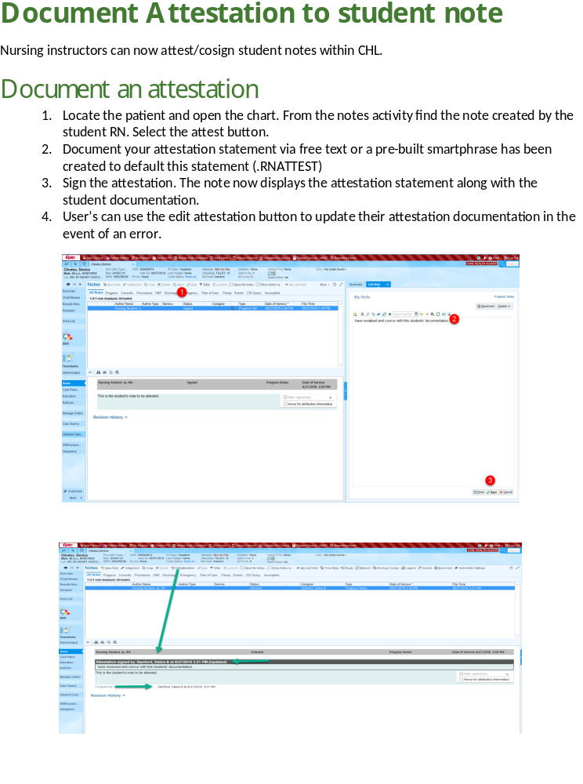

RESOURCES

Clinical Department Information – lists departments by hospital campus. Provides a description of patient population and department leader contact information. This document is updated semi-annually and posted on the Nursing Student Resources / Clinical Instructor webpage.

Cone Health uses a vast resource tool called Clinical Key for Nursing and Clinical Skills Nursing Procedures. You will find information about medical diagnoses, medications, labs and procedures.

Students are required to look up and follow the Cone Health procedure for doing a skill at a Cone Health facility.

The path to find these nursing clinical resources:
SharePoint / Personal page / Resources / Clinical Key for Nursing / Clinical Skills Nursing Procedures / View Skills / type the name of the skill you want to see.

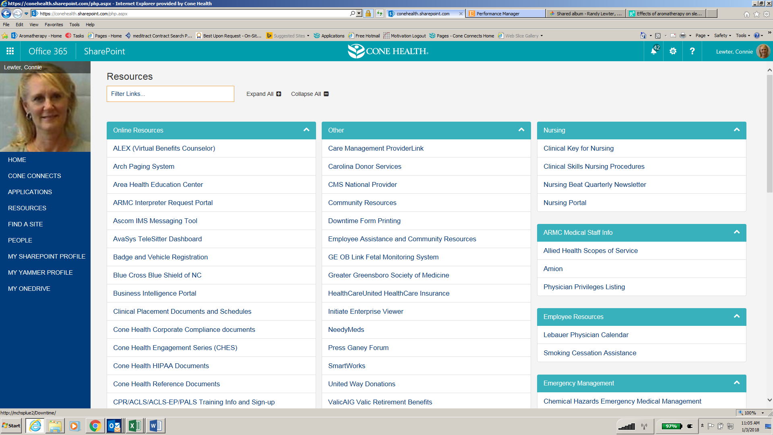
Nursing Clinical Resources

Please contact Connie or Staff.Education@ConeHealth.com if you are unable to access these resources.
Policies and Procedures

Policy Title:
Medication Safety and High-Alert Medications
Department Responsible:  Pharmacy | Policy Code:  PR-PHA-2003-74 | Effective Date:  June 5, 2015 | Next Review/Revision Date:  April 2018
Title of Person Responsible:  Executive Director of Pharmacy | Approval Council:  Medical Executive Committee |  | Date Approved by Council:  August 2003

PURPOSE:
To assure the safety of our patients by utilizing specific monitoring and double checks for identified medications.

POLICY:
High-alert medications are those listed below and will be safely administered to the patient through the use of specific processes. In order to keep our patients safe, we use Pyxis profiling, barcoding, CPOE (computerized physician order entry), smart infusion pumps, dual sign-off by nursing staff for certain high-alert medications, medication safety software for pharmacists, and other processes to enhance patient safety in medication ordering, preparation, and administration.

PROCEDURE:

Safety of Specific High-Risk Medications:
Medications in this section have specific tasks assigned to assure safety in preparation and delivery:
- Continuous Drug Infusions: All continuous drug infusions are categorized as high risk and are used in conjunction with a smart infusion pump system including guardrails. In addition, continuous drug infusion concentrations have been standardized. Periodic studies are performed to measure the use of smart infusion guardrail use.
- Chemotherapeutic Agents: In addition to nursing double check policy, special double checking procedures, standard competencies, and policy revision take place within the Pharmacy Department.
- Concentrated Electrolytes: Concentrated electrolytes are not stored as a floor stock item. These are prepared and dispensed by Pharmacy.
- Insulin: Insulin U-500 is a concentrated insulin for which specific Cone Health Pharmacy procedures and education have been developed. The procedure is attached to the medication entry in the electronic medical record.
- Neuromuscular Blocking Agents: Special labeling and colored storage bins are used (in pharmacy and nursing units outside of the operating room).
- NICU Medications:
- Syringes given by RN on the NICU are drawn up in pharmacy using a two-provider check.
- Neonatal drug therapy has been standardized in the Pharmacy Department and floor stock on the nursing unit has been severely restricted.
- Promethazine (Phenergan®) Injection: Special label precautions are given to nurses that administer IV promethazine. Dosing adjustments are made based on age and LFTs. (Pharmacy and Therapeutics Committee directive.)
- Renally Cleared Medications: Clinical information system and decision support alerts are combined with pharmacist review to assure correct dosing.
- Sound-Alike/Look-Alike Medications: There is special emphasis on this topic with a multidisciplinary medication safety team. Examples include posted TALL MAN lettering for medication name (e.g., on storage location, in Pyxis, in infusion pumps), ancillary labels (“STOP – Look / Sound-Alike Drug”) placed on medication storage locations (in pharmacy, Pyxis, etc.). See attached list of sound-alike/look-alike medications and mechanisms to reduce risk.
- Tissue Plasminogen Activator (tPA, alteplase, Activase®) for Stroke:
- The Pharmacy, Emergency Department or Administrative Coordinator will use the stroke calculator program to print out explicit instructions for programming the infusion pump.
- The first RN, along with a second RN watching, will program the pump to deliver the correct bolus and infusion dose of tPA from the stroke calculator instruction sheet.

High-Alert Medications Requiring a Double Check:
The following medications are considered high-alert medications and require a double check verification process prior to administration. High-alert medications in this category require documentation of the double check on the electronic medication administration record (eMAR).
- Insulin injections.
- Tissue plasminogen activator (tPA, alteplase, Activase®) for stroke.
- Chemotherapeutic agents.
- Patient-controlled analgesia (PCA).
The verification process includes correct medication, dose, and route for selected patient. Documentation will include the verification in the eMAR.
The following may perform the double-check process:
- Pharmacist/Pharmacist
- RN/RN (or LPN)
- Pharmacist/Provider
- RN/Pharmacist
- RN/Provider
- CareLink may use RN and paramedic for verification

REFERENCES/LINKS:
- Cone Health Sound-Alike/Look-Alike Medications Poster
- Cone Health Sound-Alike/Look-Alike Medication List
- Cone Health High-Alert Medications Poster
- Institute for Safe Medication Practices. Independent double checks: undervalued and misused: selective use of this strategy can play an important role in medication safety. ISMP Medication Safety Alert! 2013 Jun 13. Accessed 3 April 2015 from http://www.ismp.org/newsletters/acutecare/showarticle.aspx?id=51

PREVIOUS REVISION/REVIEW DATES:
Date | Reviewed | Revised | Notes
August 1, 2003 |  |  | Original effective date
January 2005 |  | X
January 2006 |  | X
September 2009 |  | X
September 2011 | X
December 2011 |  | X
August 2013 |  | X
October 2013 | X
April 2014 |  | X
May 4, 2015 |  | X | Updated hyperlinks. Updated formatting to match current policy template. No content changes.
June 5, 2015 |  | X | Added PCA to list of medications requiring double-check, added hyperlink to high-alert meds poster.
Cone Health HLC and Pyxis Access for Instructors

HealthStream (HLC)
HLC is Cone Health’s Learning Management System. CIs who are employees can access HLC with their employee log-in.

ON HOLD – A NEW PROCESS TO BE ESTABLISHED. 7.24.19 CL
Non-employees will need to contact staff.education@conehealth.com for a Contract Employee Lawson Form and instructions.

HLC access is a requirement (initiated Spring 2019) and a means for Clinical Instructors to be able to meet some of the annual required competencies.

Non-Cone Health Employee – Clinical Instructors
- Obtain the Contract Employee Lawson form from Staff Education during your New Clinical Instructor meeting.
- Send the completed form, EXCEPT FOR YOUR SSN, to Staff.Education@ConeHealth.com.
- To protect your identity, you will need to phone Teresa Timmons, Human Resources Specialist, directly at 336.832.6059, or phone Connie, 336.553.6053 with your SSN then Connie will phoneTeresa. You will receive an ID and instructions to log into HealthStream (HLC).
- In HLC (Learning Management System) go to Catalog and search for Pyxis ED v1.4: Clinician Workflow (Profile).
- Once you have completed the Pyxis module, Connie Lewter, the Department Director or Assistant Director will need to send an email to the appropriate Pyxis (MC/WL/WH/AP/AR) address (students do not document at BH) to request access for you. You will receive access in 24 hours.

Cone Health Nurse – Clinical Instructors
- Use your EID to access HLCs.
- If you have access to Pyxis as an employed nurse, the pharmacy has determined that you will use the same Pyxis log-in for your work as a Clinical Instructor.

- If you are on a different department, you may need the Director or Assistant Director email the local pharmacy and request access for you on that department.

- If you have not had access to Pyxis in your employee role, you will need to complete the Pyxis tutorial that is in HLC.

- Connie Lewter, the Department Director or Assistant Director will need to send an email to the appropriate Pyxis MC/WL/WH/AP/AR address (students do not document at BH) to request access for you.

There are several Pyxis tutorials listed in HLC. Select:
Pyxis ED v1.4: Clinician Workflow (Profile)
New Department Orientation

Established Clinical Instructors going to a new department are required to complete an 8-hour orientation to the department. Refer to the Clinical Instructor Reference Guide for orientation guidance.

Department leaders may determine there are specific competencies for clinical instructors such as Safe Patient Handling equipment, IV care and medications, wound care or anything that pertains to the student role on the department. List these specific competencies and when completed, have your preceptor or department leader initial the competency.* Do not leave blank; if there are no identified CI department competencies write No identified CI department competencies, then have your preceptor or department leader initial the statement. As part of your orientation to the department, list the annual department specific competencies and the validation method you used to meet the requirement. Do not leave blank; if all competencies are beyond the nursing instructor role, write Annual department competencies are beyond the generalist nurse and have your preceptor or department leader initial

Cone Health Hospital Campus / Department:
Department Orientation competencies: | Initials
Instructor Signature: Date: ___________________
Comments:
Required Department Orientation Preceptor/ Qualified Observer / or assigned resource staff nurse *
Signature: Date: ___________________
Comments:
TURN this form into the Education Partner at YOUR SCHOOL who will sumbit to Staff.Education@ConeHealth.com.

Clinical Instructor Fast Facts

Clinical Instructor (CI) Requirements

Each semester, review Clinical Instructor Reference Guide (CIRG). Practices updated frequently.
Prior to starting on a Student Group (base) department and for Out-Rotation sites:

- Complete orientation and annual competencies for each department you go to, before beginning with students. This is due prior to beginning the clinical rotation with students.
- New – Departments may determine that there are competencies relevant to CIs. An area to include these has been added to the Competency form.
- Contact department leadership to let them know you are coming and see if they want to meet with you or have any information for you. This contact is to allow for two-way communication.
- Review the Student and Clinical Instructor Department Information document (in CIRG and on website) with department leadership; place a copy in the Student Information binder.
First day of Clinical

- Orient students to department using Clinical Department Orientation Guide and Instructor Commitments for a Successful Clinical document in the CIRG as a guide.
- Complete /students sign the Clinical Department Orientation form; give to Education Partner.
Daily

- Post Assignment – required. See CIRG for information to include on assignment form.
- Leave a copy of the assignment in the Student Information Binder
- Speak with each nurse working with your students at the beginning and end of the shift.
- Ensure students are prepared to attend report on their patients at the beginning of the shift.
- Seek formative feedback from the staff and share thoughts about how the clinical is going.
- Medication administration – an Instructor or RN must be with the student throughout the entire medication administration process. Do Not Over-Ride warnings before looking at the reason.
- Discharge teaching – An Instructor or Nurse must be with the student when providing Discharge Instructions.
- New Alert - Isolation patients – students are not fit-tested so they cannot be assigned to care for TB or other reverse isolation patients.
- New Alert – Co-Signature requirement for all student documentation

Last Day of Clinical
- Direct students to complete a Student Survey posted on the Clinical Placement website.
- Complete the Clinical Instructor Survey
Support

Nursing Student Experiences website – contains all documents and froms related to student clinicals: https://www.conehealth.com/health-care-professionals/nursing-student-resources/

- Clinical Instructor Reference Guide (CIRG)

- Student Clinical Policy – posted on the Clinical Placement webpage, contains information regarding supervision, medication administration and dress code.

- Clinical Key & Clinical Skills
  - Clinical Skills – Nursing Procedures. Review prior to doing a new procedure
  - Clinical Key for Nursing contains information on diagnoses, meds, labs
  - Pathway(s) – From SharePoint landing page when you sign in to Cone Health, go to Resources or Find a Site / Cone Health Nursing / Clinical Skills or Clinical Key

- CHL – Reset Password via IT Help ticket accessed through Cone Connects or call Assist Desk 336.832.4272. Students use school ID#s for SSN. Email request form per instructions on form obtained through Staff Ed or school. conehealthprod@service-now.com. Employees cannot use employee log-in.

- Pyxis – Complete the Pyxis tutorial (CIRG) and test then give the Certificate of Completion to the department leadership to contact the local pharmacy to create their log-in access.
- Badges – secserv1@conehealth.com or 336.832.7849. Request form obtained through Staff Ed and to be submitted by the school Education Partner. All badge issues are managed directly with badge security. Employees cannot use their employee badge. Collect and return badges upon graduation or leaving program to avoid fees.

- HLCs (Healthstream, Learning Management System)

- The Department leadership is available to help with any issues or concerns you may have.

- For additional support, Contact Connie Lewter, Connie.Lewter@conehealth.com 336.553.6053 or Staff.Education@ConeHealth.com

Cone Health would like to
thank you for your partnership
with us in providing
exceptional care for our patients
and exceptional learning experiences
for your students.

Update: July 2019 CL

